**Financial Forecast**

Recursion is a technique where a function calls itself to solve a problem by breaking it down into smaller subproblems. The following code where we calculate future value of initial investment using the formula:

Future_value(years) = Future_value(years - 1) * (1 + Growth_rate)

OUTPUT:

Sample Output 1:

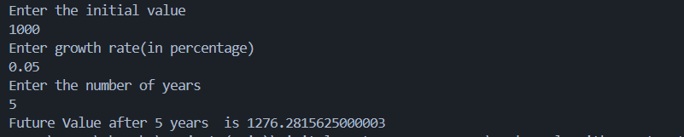

Sample Output 2:

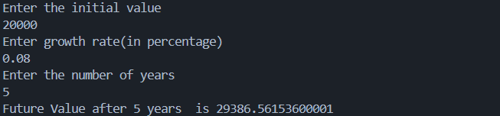

Time Complexity:

The time complexity of this algorithm will be O(n) as this program will recursively call itself n times which is number of years here.

Optimizing Solution:

There will be an optimization problem in this code when the value of n which is number years will increase (large value like n=1000), therefore there is a need of optimization.

Another approach that can be used is:

public static double calculateFutureValueIterative(double initialValue, double growthRate, int years) {

double result = initialValue;

for (int i = 0; i < years; i++) {

result *= (1 + growthRate);

}

return result;

}